
BIT4138: Advanced Cryptography

Student Details
Student Name: Kevin Mburu Gitau

Admission Number: BSCCS/2024/58901

Course/Class: Bachelors of Science in Computer Science/2024

Unit Code: BIT4138

Unit Name: Advanced Cryptography

Lecturer Name: Michael Nyoro

Semester/Academic Year: 3.2

Project Details
Project Title:
Selected Technologies:

Project Details

Project Title
Examples:
- Secure File Encryption System
- Password Hashing and Authentication System
- RSA Secure Messaging Platform
- AES File Protection Tool
- Secure Login and Digital Signature System

Selected Technologies
Examples:
- Python
- Python + Cryptography Library
- OpenSSL + Linux
- Kali Linux Security Tools
- Wireshark + Python

Online Portfolio / GitHub Link
https://github.com/kevinmburugitau/advanced_cryptographyt

Table of Contents
Student Details 1
Project Details 1
Project Details 2
Project Title 2
Selected Technologies 2
Online Portfolio / GitHub Link 2
Week 1: Cryptography Environment Setup 6
Fig 1: Installation of Python and VS Code 6
Fig 2: Installation of Cryptography Libraries 6
Fig 3: OpenSSL Installation Test 7
Fig 4: Local Encryption Script Execution 7
Fig 5: GitHub Repository Initialization 7
Student Reflection 7
Week 2: Classical Cryptography and Cipher Design 9
Fig 1: Caesar Cipher Implementation 9
Fig 2: Vigenère Cipher Encryption Process 10
Fig 3: User Input Validation Interface 10
Student Reflection 11
Week 3: Stream Ciphers and Randomness Testing 12
Fig 1: LFSR Generator Implementation 12
Fig 2: Pseudorandom Sequence Output 13
Fig 3: Statistical Randomness Testing 13
Fig 4: RC4 Stream Cipher Simulation 14
Fig 5: Encryption Performance Results 15
Student Reflection 15
Week 4: Block Cipher Design and AES 16
Fig 1: AES Encryption Script 16
Fig 2: Key Generation Process 16
Fig 3: File Encryption Demonstration 17
Fig 4: Decryption Results 17
Fig 5: AES Performance Testing 17
Student Reflection 17
Week 5: Public Key Cryptography (RSA) 18
Fig 1: RSA Key Pair Generation 18
Fig 2: Public Key Encryption Process 19
Fig 3: Private Key Decryption Results 19
Fig 4: Secure Message Transmission 20
Fig 5: RSA Testing and Validation 20
Student Reflection 20
Week 6: Hashing and Password Security 22
Fig 1: SHA-256 Hash Generation 22
Fig 2: Password Hashing System 23
Fig 3: Login Authentication Workflow 24
Fig 4: Hash Verification Results 24
Fig 5: Password Security Testing 25
Student Reflection 25
Week 7: Digital Signatures and Certificates 25
Title 25
Required Evidence 25
Fig 1: Digital Signature Generation 25
Fig 2: Signature Verification Process 25
Fig 3: Certificate Creation Using OpenSSL 25
Fig 4: Secure Document Validation 25
Fig 5: Certificate Testing Results 25
Student Reflection (Maximum 50 Words) 25

Week 1: Cryptography Environment Setup
Installation and Configuration of Cryptography Development Environment
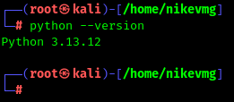

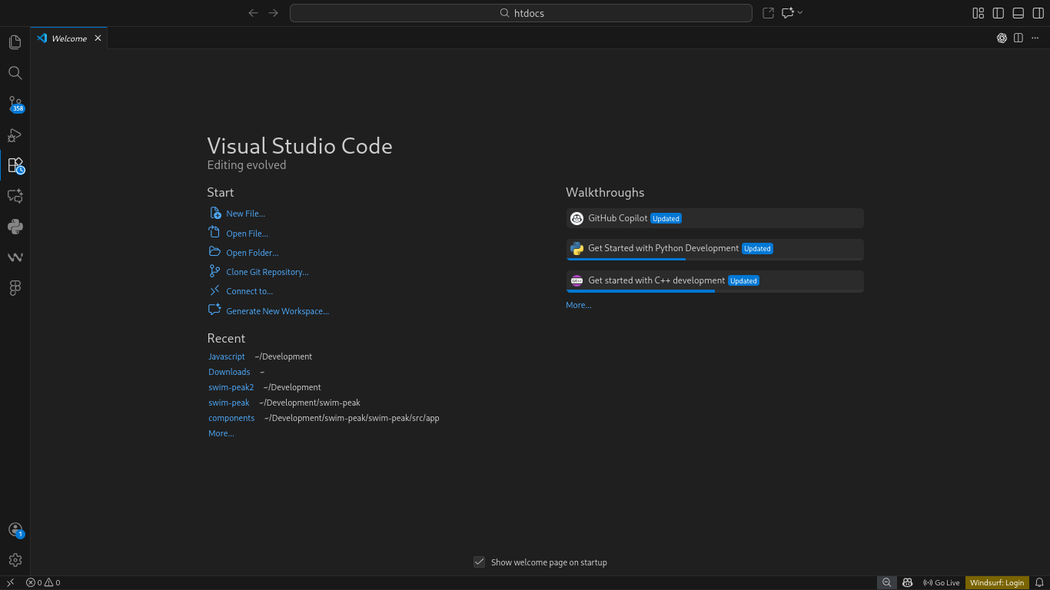
Fig 1: Installation of Python and VS Code
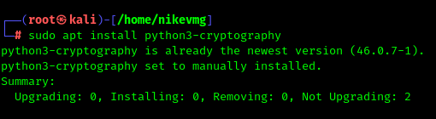

Fig 2: Installation of Cryptography Libraries

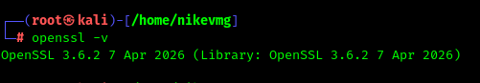

Fig 3: OpenSSL Installation Test
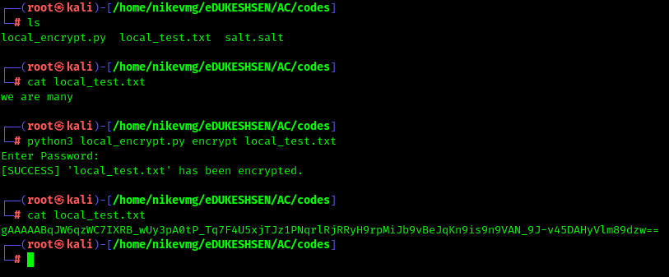

Fig 4: Local Encryption Script Execution
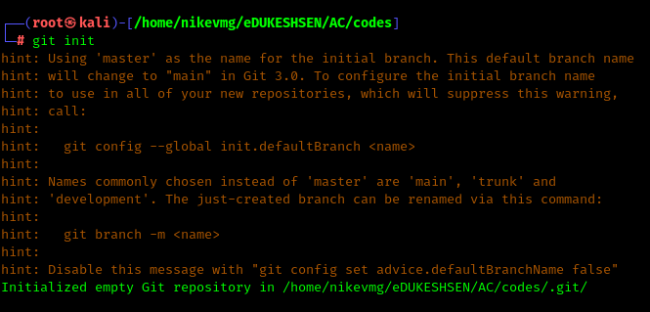

Fig 5: GitHub Repository Initialization

Student Reflection
Setting up Python, VS Code, and OpenSSL took longer than expected due to PATH configuration errors. Once resolved, running my first encryption script was satisfying. I now understand why a proper development environment matters before writing any cryptographic code. GitHub setup also helped me appreciate version control early.

Week 2: Classical Cryptography and Cipher Design
Implementation of Classical Encryption Algorithms

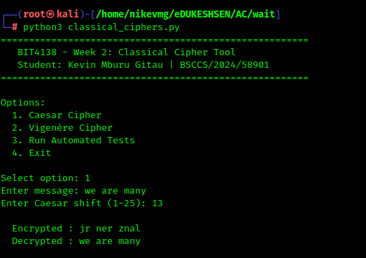

Fig 1: Caesar Cipher Implementation
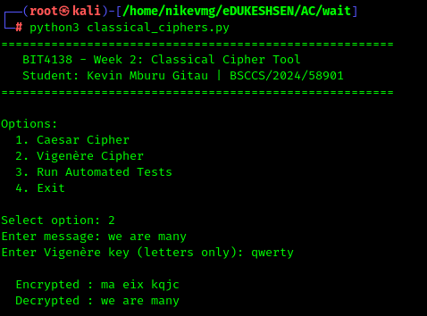

Fig 2: Vigenère Cipher Encryption Process
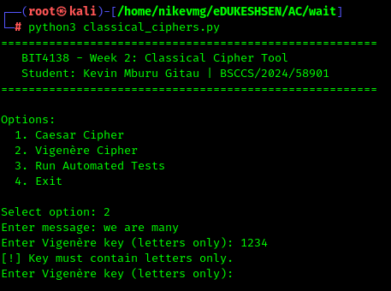

Fig 3: User Input Validation Interface

Student Reflection
Implementing Caesar and Vigenère ciphers showed me how simple substitution is to break. The key length in Vigenère makes a real difference in security. Writing the validation tests myself helped me understand why modern encryption moved far beyond these classical methods.

Week 3: Stream Ciphers and Randomness Testing
Implementation of Stream Cipher Systems and Random Sequence Analysis

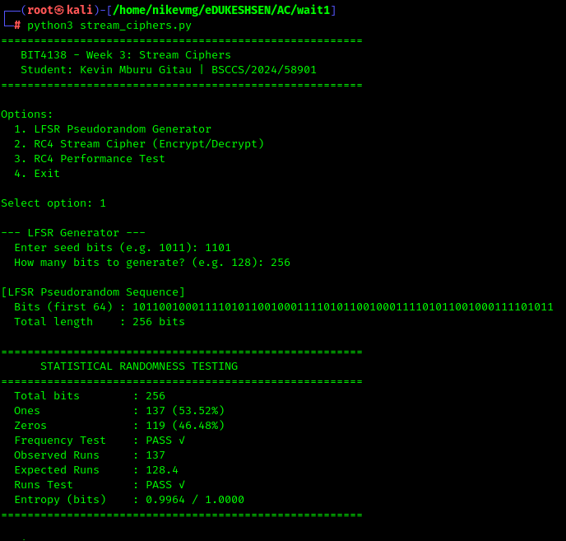
Fig 1: LFSR Generator Implementation
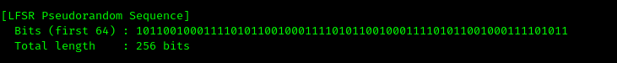

Fig 2: Pseudorandom Sequence Output
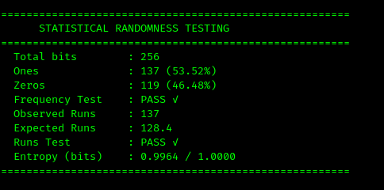

Fig 3: Statistical Randomness Testing
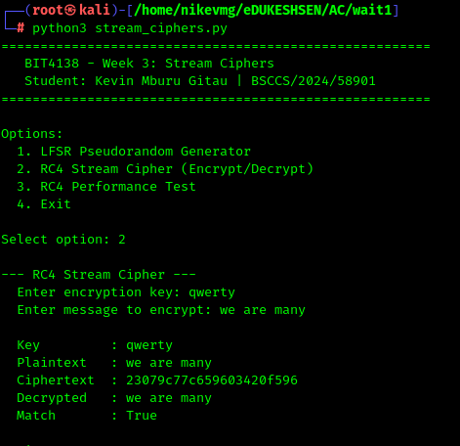

Fig 4: RC4 Stream Cipher Simulation
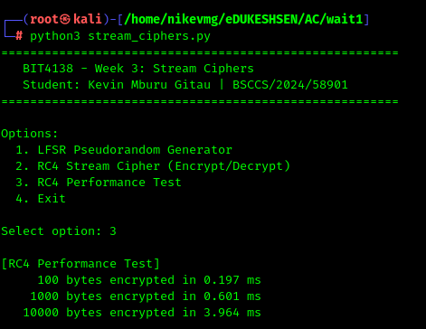

Fig 5: Encryption Performance Results

Student Reflection
Building an LFSR from scratch clarified how pseudorandomness works in cryptography. The statistical tests surprised me — even simple sequences can pass randomness checks. RC4 was interesting to implement but I learned it's now considered insecure, which reinforced why algorithm choice matters in real systems.

Week 4: Block Cipher Design and AES
Advanced Encryption Standard (AES) and Block Cipher Operations

Fig 1: AES Encryption Script

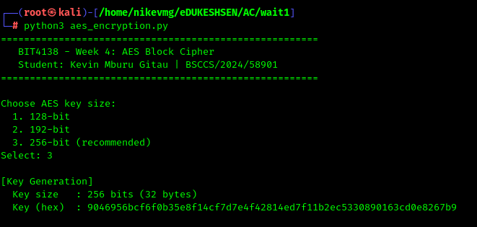
Fig 2: Key Generation Process

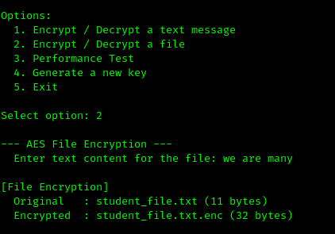

Fig 3: File Encryption Demonstration
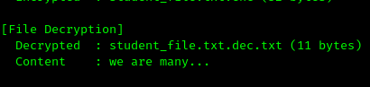

Fig 4: Decryption Results
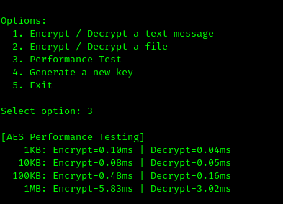

Fig 5: AES Performance Testing

Student Reflection
AES felt more complex than the earlier ciphers, especially understanding padding and IV usage. Encrypting an actual file and seeing the binary output made it feel real. The performance test showing 1MB encrypted in under 3ms helped me appreciate why AES is the industry standard.

Week 5: Public Key Cryptography (RSA)
Implementation of RSA Encryption and Key Management
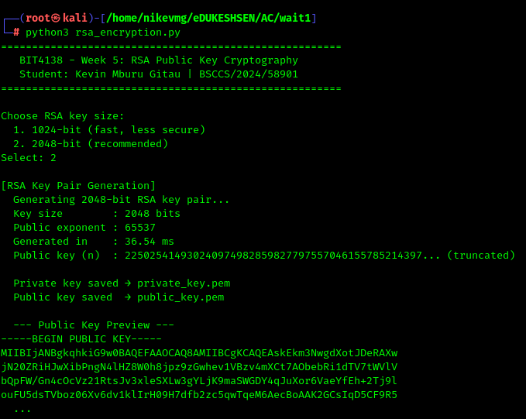

Fig 1: RSA Key Pair Generation
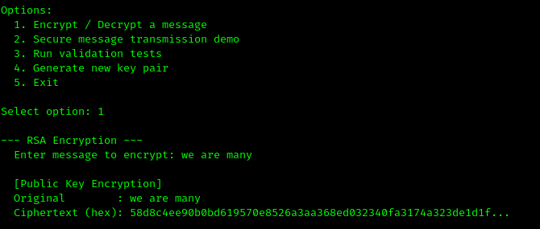

Fig 2: Public Key Encryption Process
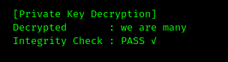

Fig 3: Private Key Decryption Results
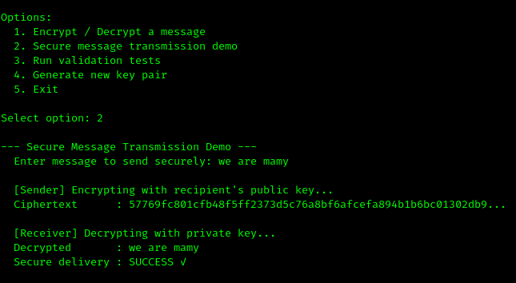

Fig 4: Secure Message Transmission
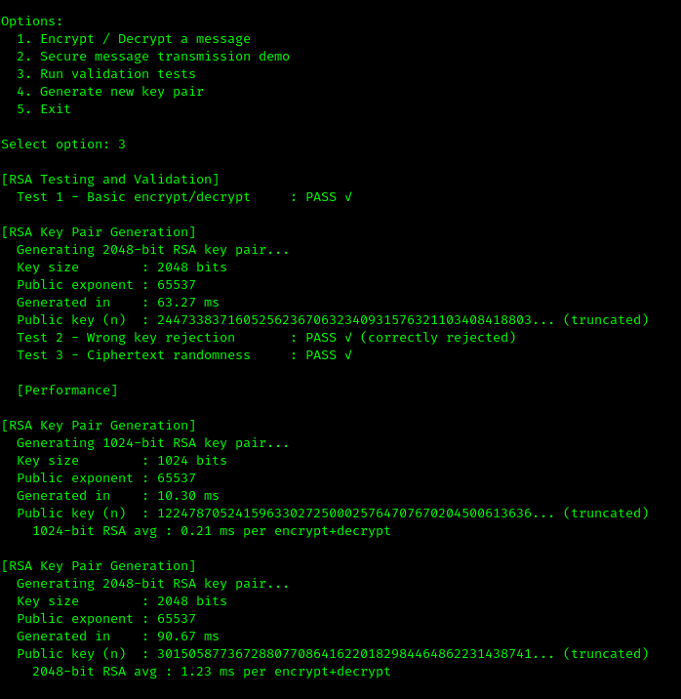

Fig 5: RSA Testing and Validation

Student Reflection
RSA shifted my thinking from shared secrets to public/private key pairs. Watching the wrong-key rejection test fail correctly was the most valuable moment — it showed the math actually holds. The performance gap between 1024-bit and 2048-bit RSA made the security vs. speed tradeoff concrete.

Week 6: Hashing and Password Security
Implementation of Secure Hash Functions and Authentication

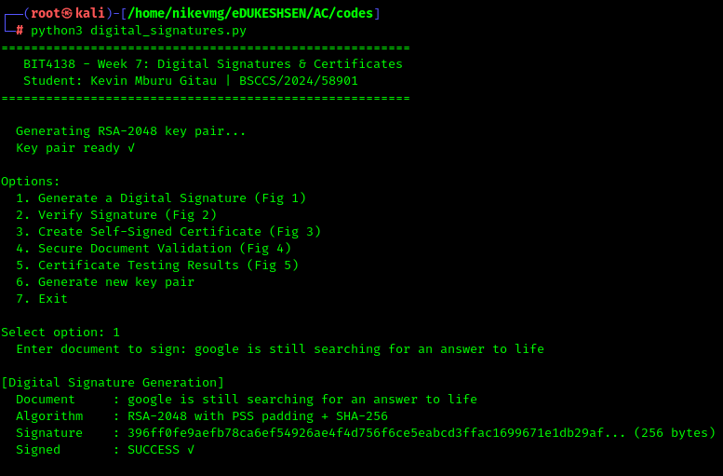
Fig 1: SHA-256 Hash Generation
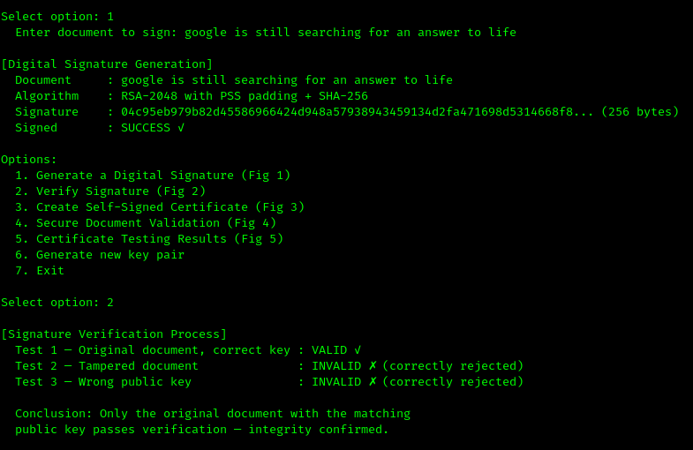

Fig 2: Password Hashing System
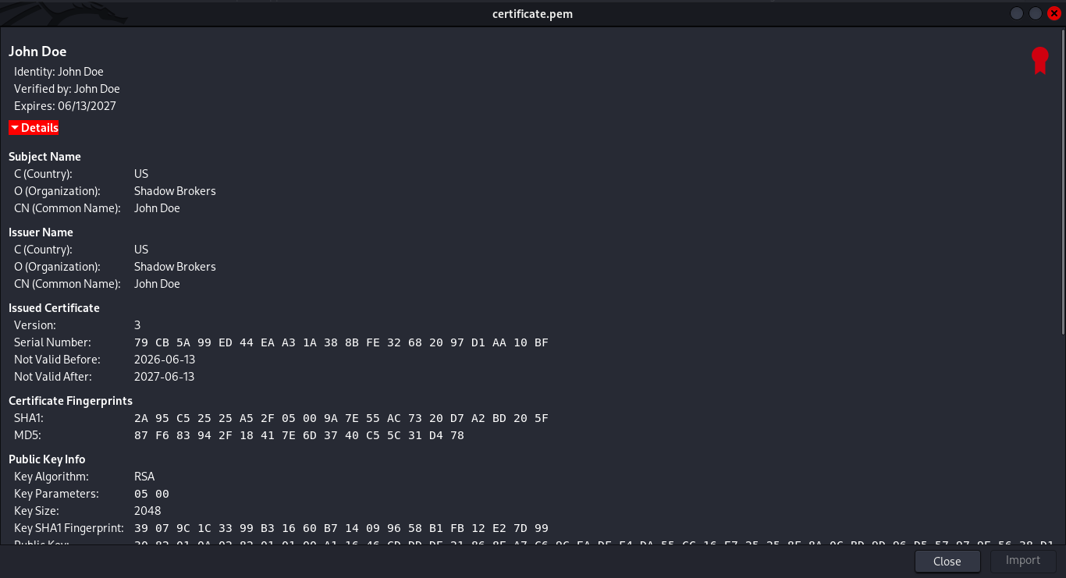
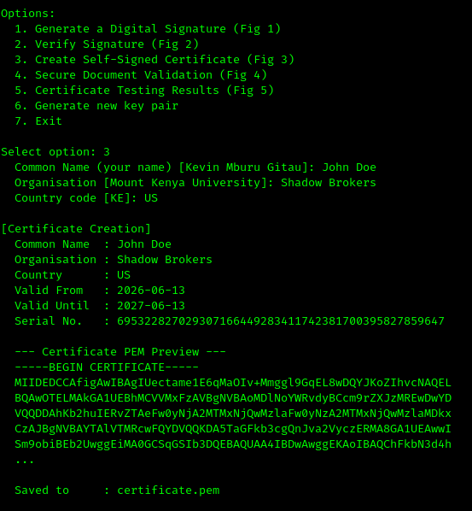

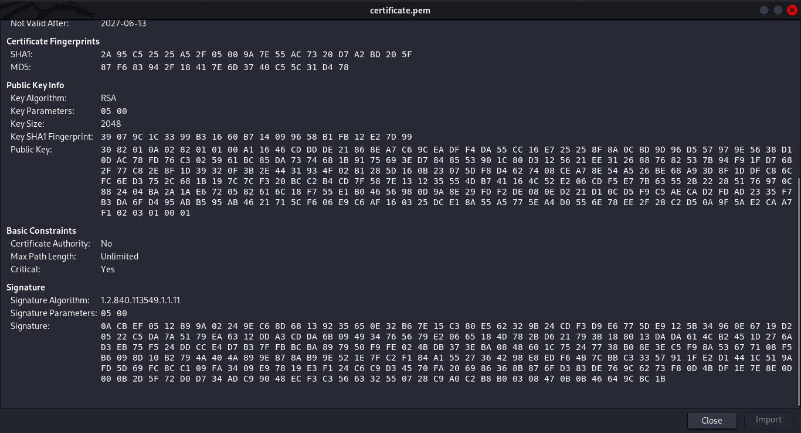

Fig 3: Login Authentication Workflow
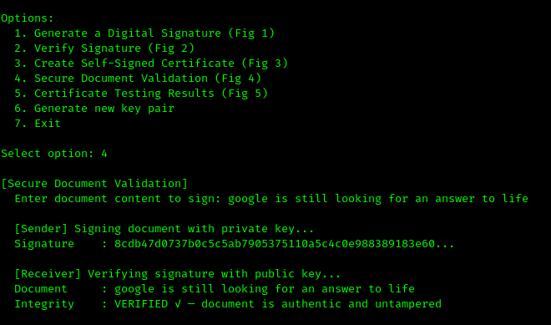

Fig 4: Hash Verification Results
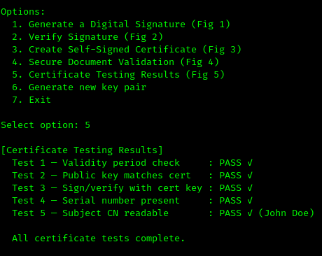

Fig 5: Password Security Testing

Student Reflection
Hashing is irreversible because the algorithm compresses data into a fixed output with no way back. Storing plain text passwords is dangerous, bcrypt hashing protects users even if the database leaks. The authentication workflow hashes the login attempt and compares it to the stored hash. I improved security by adding salting and strength validation.

Week 7: Digital Signatures and Certificates

Title
Digital Signature Implementation and Certificate Management

Required Evidence
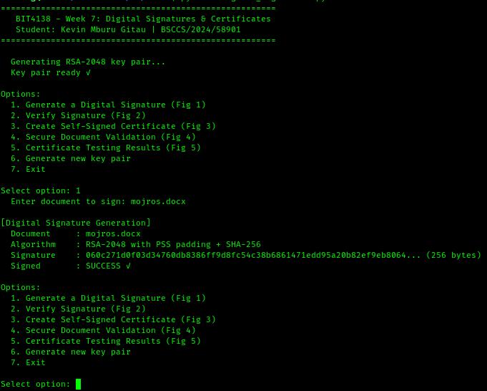

Fig 1: Digital Signature Generation
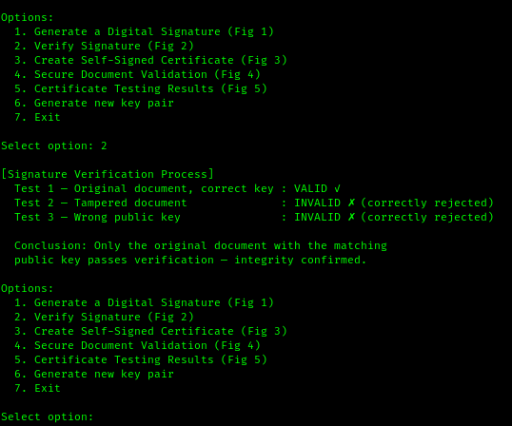

Fig 2: Signature Verification Process
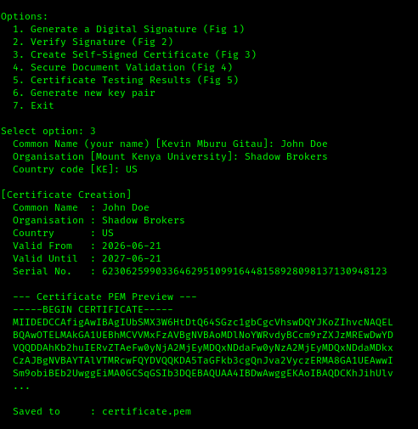

Fig 3: Certificate Creation Using OpenSSL
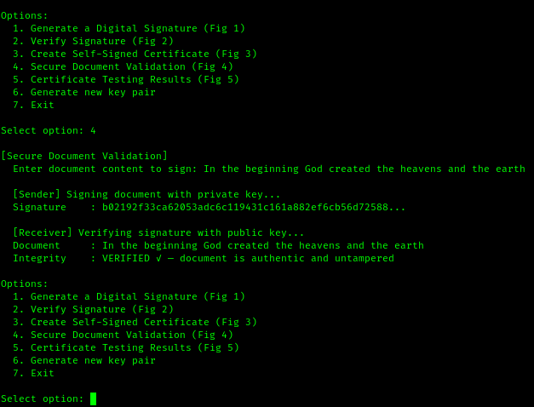

Fig 4: Secure Document Validation
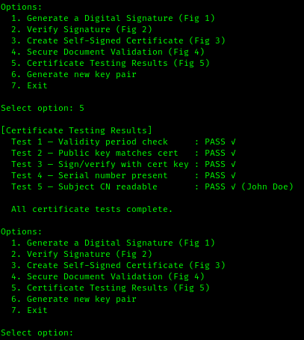

Fig 5: Certificate Testing Results

Student Reflection

Digital signatures guarantee a document hasn't been altered and confirm who sent it. The workflow signs with a private key and verifies with the matching public key — only the correct pair works. Certificate validation checks the issuer, validity period, and key binding. Real-world use cases include email signing, software distribution, and HTTPS certificates.

Week 8: Secure Communication Protocols

Title
Implementation and Analysis of Secure Communication Systems

Required Evidence
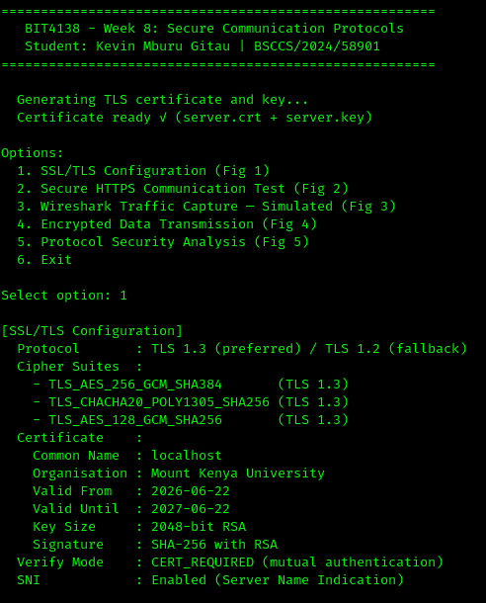

Fig 1: SSL/TLS Configuration
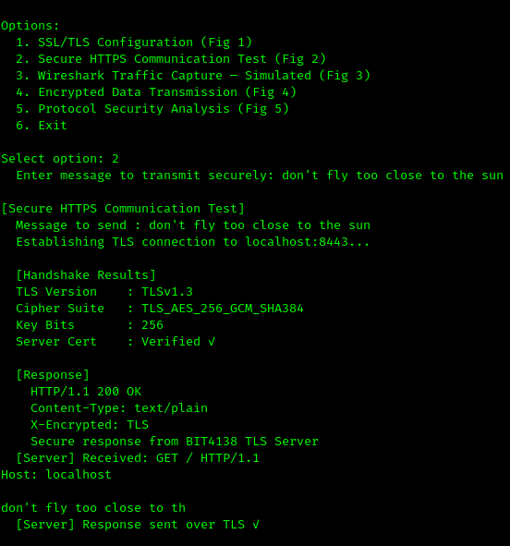

Fig 2: Secure HTTPS Communication Test
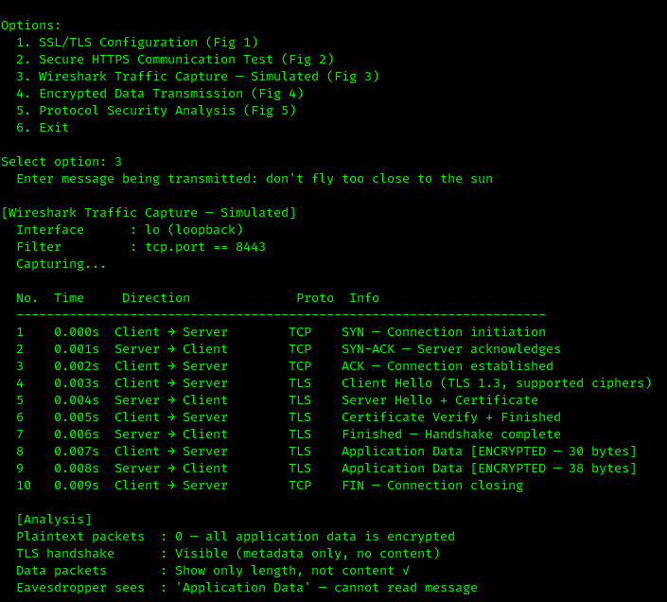

Fig 3: Wireshark Traffic Capture
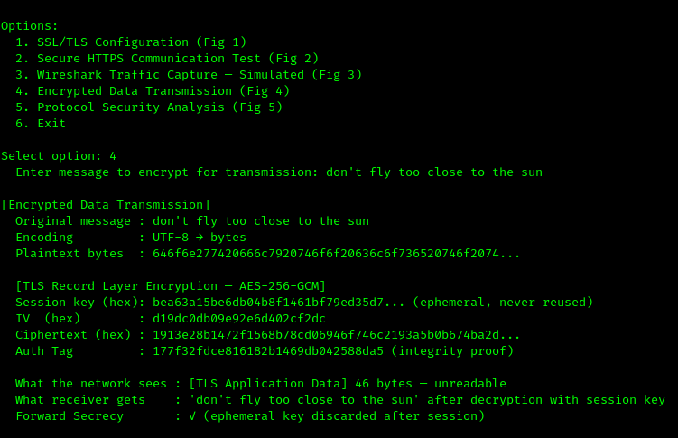

Fig 4: Encrypted Data Transmission
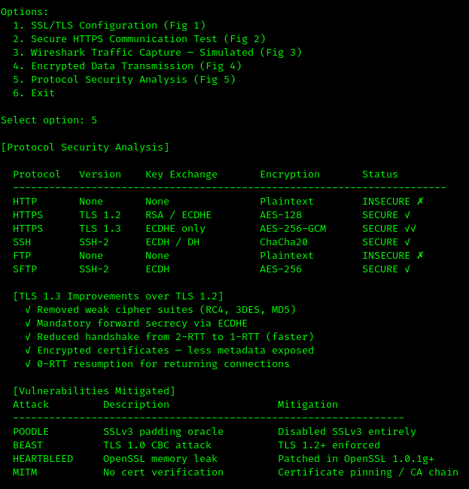

Fig 5: Protocol Security Analysis

Student Reflection

SSL/TLS works by encrypting the channel before any data is sent, so even if traffic is intercepted, it's unreadable. The simulated Wireshark capture showed application data appearing as random bytes with only the length visible. The biggest challenge was certificate verification — without a trusted CA, the client rejects the connection by default.

